**UNIT 5: COMPUTER USAGE**

**OBLIGATION – PROHIBITION – PERMISION - SUGGESTION - ABILITY - ABSENSE OF OBLIGATION**

En esta unidad vamos a aprender sobre un grupo de verbos muy especiales, los modal verbs o verbos modales. Hay unos 12 verbos modales en inglés, (el número varía según los autores), pero acá sólo estudiaremos los referidos a:

* rules, obligations or necessity (reglas, obligaciones o necesidad)
* absence of obligation or necessity (ausencia de obligación o necesidad)
* ability (habilidad)
* suggestion (sugerencia)

Los verbos modales son especiales porque:

* su significado es incompleto, expresan una idea como la de obligación, pero necesitan de otro verbo, el verbo principal que complete este significado para aclarar obligación de qué. El modal must, por ejemplo equivale a ‘deber’, en el sentido de obligación en castellano. Si digo I **must** = **Debo**, pero no agrego otro verbo para aclarar qué es lo que debo hacer, la idea no está completa. Con un verbo principal, se completa el sentido: I **must** **pass 80% of the assignments.** (Debo aprobar el 80% de los trabajos prácticos.)
* actúan como auxiliares, es decir preguntan y niegan por sí mismos.

I **must not / mustn’t submit assignments out of term.** (No debo enviar prácticos fuera de término.)

* el verbo que los acompaña está siempre en infinitivo. (Después de un modal, el verbo principal no se conjuga, es decir no lleva ‘s’, ‘ing’, ‘ed’ o formas irregulares.)

**LOOK!**

**Los sujetos que suelen acompañar las reglas y obligaciones son ‘You’, ‘We’** y  **‘I’**

|  |  |
| --- | --- |
| must, mustn’t, can, can’t, have to, don’t have to, should, shouldn’t | |
| RULES | EXAMPLES |
| We use **must** and **have to** for obligations. | You **must / have to** come to classes on time. |
| We use **mustn’t and can’t** for prohibitions. | You **mustn’t / can’t** smoke here. |
| We use **can** and **can’t** for possibility and ability. | I **can** eat outside the computer lab (it is possible, I have permission)  I **can** use excel but I **can’t** use PowerPoint. (ability) |
| We use **don’t have to** when something is not necessary. | I **don’t have to** work at weekends. |
| We use **should** and **shouldn’t** for strong recommendations and advice. | You **should** keep your desk clean.  You **shouldn’t** share your password. |

1. [▶ Leé y escuchá a Ben](https://virtual.unju.edu.ar/pluginfile.php/242993/mod_resource/content/1/Rules%20of%20computer%20use..mp3) hablando acerca de las normas relacionadas con el uso de la computadora en su trabajo.
2. ¿Podés identificar dos prohibiciones? I can’t Access some websites – I mustn’t eat food at my desk or put drinks on the computer.
3. ¿Podés identificar dos obligaciones o cosas que es muy necesario que sean hechas? I must update my calendar all the time. I have to log in using my user name and password.
4. ¿Podés identificar algo que se sugiere no hacer, aunque no llega a ser una prohibición? I shouldn’t use my date of birth in my password.
5. ¿Podés identificar algo que se sugiere hacer, aunque no llega a ser una regla? I should take a break ebery two hours.
6. ¿Podés identificar una habilidad o algo que Ben sabe hacer? I can use Excel.
7. ¿Podés identificar algo que no es necesario que Ben haga? I don’t have to back up files every day.

*Hi, I'm Ben. I'm an analyst programmer and I work for the university. These are the rules about the use of computers in my office*

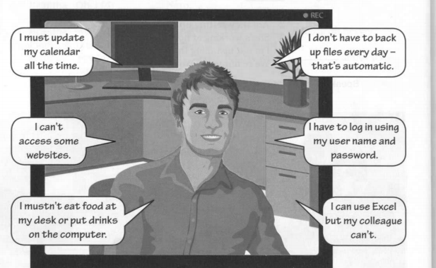

I shouldn’t use my date of birth in my password.

I should take a break every two hours.

1. I **must** update my calendar all the time. → It is necessary / It is not necessary.
2. I **mustn’t** eat food at my desk or put drinks on the computer. → It is an ability / It is a prohibition.
3. I **don’t have to** back up files every day, it’s automatic. → It’s a prohibition / It is not necessary.
4. I **have to** log in using my user name and password. → It is an ability / It is necessary.
5. I **can** use Excel but my colleague **can’t**. → It is an ability / It is a good idea.
6. I **can’t** access some websites. → It is an obligation / It is a prohibition.
7. I **should** take a break every two hours. →It is an ability / It is a good idea.
8. I **shouldn’t** use my **date of birth in my password.** →It is necessary / It is not a good idea.

3. Read again and answer the questions.

1. What **does** Ben **have to** do? He **has to** log in using his user name and password.
2. What **can** Ben do? He **can** use Excel.
3. What **mustn’t** Ben do?

……………………………………………………………………………………………………………………………………………………………………

1. **Can** he open any website?

……………………………………………………………………………………………………………………………………………………………………

1. What **doesn’t he have to** do every day?

……………………………………………………………………………………………………………………………………………………………………

1. What **should** Ben do every two hours?

……………………………………………………………………………………………………………………………………………………………………

1. What **shouldn’t** he do?

……………………………………………………………………………………………………………………………………………………………………

EXTRA PRACTICE

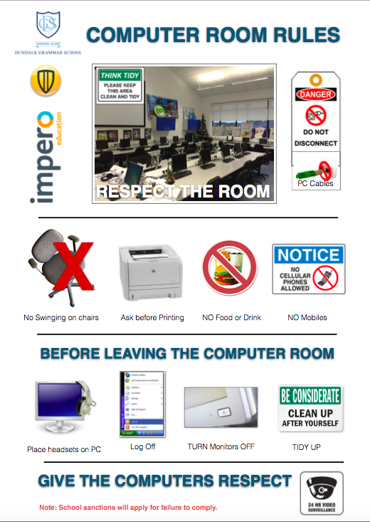2. Look at the notice in the computer room and write rules using modal verbs

You must not (mustn’t) disconnect the PC cables.

……………………………………………………………………………………………………………………………………………………………………………………………………………………………………………………………………………………………………………………………………………………………………………………………………………………………………………………………………………………………………………………………………………………………………………………………………………………………………………….

1. Complete these rules in the English classroom. Use must / mustn’t, should / shouldn’t, can/ can’t, have to / don’t have to
2. You ……………… listen carefully. ✓
3. You ……………… use your mobiles phones without permission. X
4. You ……………… leave the class before it finishes. X
5. You ……………… ask for help when you need it. ✓
6. You ………………. to buy an English text book. You can download your notes from the virtual classroom. X
7. You ……………….to arrive to class in time. ✓
8. You ………………. attend tutoring classes. ✓
9. You ……………….miss classes. X
10. You ………………. eat or drink in class ✓(you have permission), but you ……………….. drop litter on the floor.